WEARTWIN
A Smart Wearable Device for Soldier Health, Fatigue and Readiness Monitoring

1. Introduction
WearTwin is an AI-assisted wearable monitoring prototype intended to estimate a soldier’s changing physiological state by combining physiological signals, body movement and environmental context. Its pipeline connects ESP32-based sensing and signal processing with feature extraction, machine-learning state estimation and a Soldier Digital Twin dashboard. The intended focus is to make changes in strain and readiness easier to observe over time, rather than treating each sensor reading in isolation.

2. Problem Statement
Individual physiological measurements and fixed thresholds may not adequately represent a soldier’s overall strain when physical activity, environmental exposure and personal baselines change over time. WearTwin addresses the engineering challenge of combining multimodal physiological, movement and environmental data into an evolving, interpretable estimate of soldier state. The system must acquire and process noisy measurements, derive meaningful temporal features, estimate states such as fatigue, thermal strain and cardio-respiratory stress, and present the estimates through a Digital Twin and dashboard. The prototype is intended for monitoring and decision support; its model outputs are not clinically validated diagnoses or proof of fitness for operational duty.

3. Project Objectives
- Build an ESP32-based multimodal sensing platform for physiological, motion and environmental measurements.
- Apply digital signal processing to improve signal quality and derive features such as heart rate, HRV and activity indicators.
- Create a causal feature pipeline that accounts for personal baselines, temporal trends and missing sensor inputs.
- Develop and evaluate AI models for physiological-state classification and a 0–100 readiness estimate.
- Represent changing estimates in a Soldier Digital Twin dashboard for individual and squad-level monitoring.

3.1 How WearTwin Works
The intended data path is: Wearable sensors → ESP32 acquisition and DSP → time alignment → causal feature engine → AI state and readiness estimation → Digital Twin → dashboard.

01 Sense | Collect ECG/heart-rate information, PPG/SpO₂, respiration, skin temperature, movement and ambient conditions.
02 Condition | Filter signals, calculate beat/interval features where supported, assess motion artefacts and retain signal-quality information.
03 Personalise | Use an initial resting calibration period to establish personal baselines; compute deviations and trailing trends using only current and prior data.
04 Estimate | Apply the trained classifier and readiness regressor to estimate one of four states and a readiness score, with strain indices as supporting indicators.
05 Visualise | Update the soldier’s evolving Digital Twin and show status, readiness, trends and alerts in an interactive dashboard.

Model Inputs Represented in the Current AI Pipeline
Input | Role in state estimation
Heart rate (HR) | Beats per minute; relative change and short/long-term trend.
Heart-rate variability (RMSSD) | Beat-to-beat variability feature used as one indicator of physiological load.
SpO₂ | Peripheral oxygen saturation estimate from optical sensing.
Respiratory rate | Breaths per minute; level and deviation from personal baseline.
Skin temperature | Surface temperature and its change over time; not a direct core-temperature measurement.
Ambient temperature | Environmental temperature used to contextualise thermal exposure.
Relative humidity | Environmental humidity used alongside temperature in heat-load features.
IMU acceleration | Movement/activity intensity from body-worn inertial sensing.
Current software prototype: The model uses 30-second windows, a 10-minute resting baseline and 34 causal features. Synthetic-data testing reported a macro-F1 of 0.842 for state classification and a readiness MAE of 4.5 points on a 0–100 scale. These are simulated-evaluation results, not evidence of real-world physiological accuracy.
Implementation boundary
An interactive dashboard and synthetic-data AI pipeline have been developed. Embedded work includes ECG simulation/acquisition and MPU6050 orientation estimation, with PPG signal experiments also described in the presentation. A validated, end-to-end wearable stream covering all modalities is still to be integrated and tested.

4. System Architecture and Working
The architecture uses five connected stages, supported by individual baseline calibration, multimodal synchronisation and a synthetic-data/model-verification environment.
Wearable Sensor Node  Captures ECG/heart activity, PPG/SpO₂, respiration, movement, skin temperature and ambient conditions. | Edge Acquisition and DSP  ESP32 sampling and conditioning; filtering, R-peak/RR/BPM extraction, PPG denoising experiments and Kalman orientation. | Causal Feature Engine  34 features per 30-second window, including baseline deviations, rolling trends and activity/heat-exposure indicators. | AI State and Twin Engine  HistGradientBoosting estimates four states and a 0–100 readiness score; smoothing and sensor-loss handling are included in the presented pipeline. | Dashboard and Triage HUD  Displays individual/squad telemetry, readiness bands, strain indices, historical trends and simulated alerts for decision support.

5. Architecture Diagram
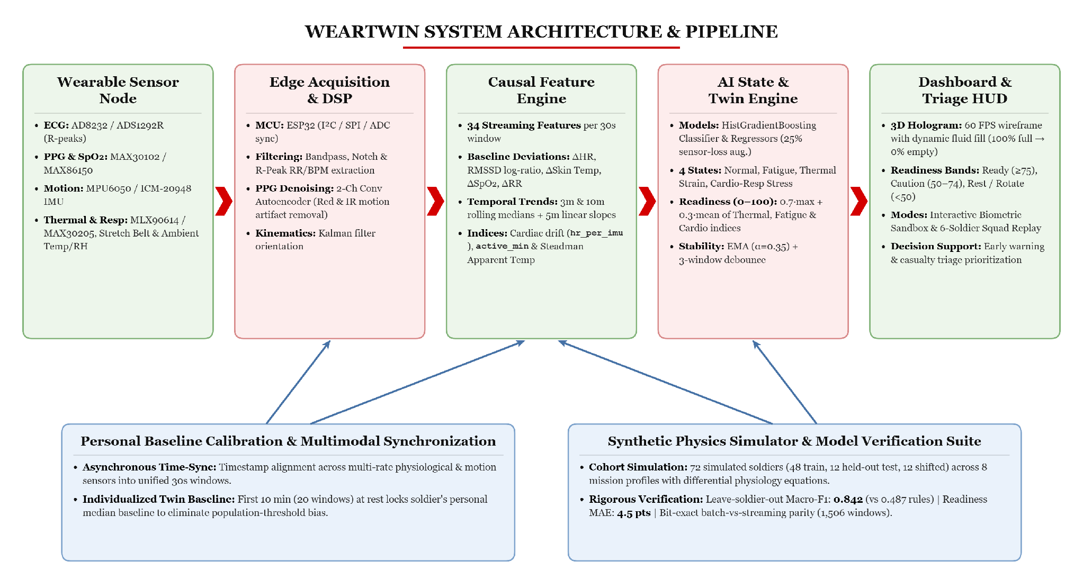

6. Literature Review — Papers Referred
Digital Twin Prospects in IoT-Based Human Movement Monitoring Model | Digital Cardiovascular Twins, AI Agents, and Sensor Data: A Narrative Review
Multimodal Predictive Analytics for Early Disease Detection Using Wearable IoMT and Artificial Intelligence | AI-Driven Smart Healthcare: Integrating Machine Learning, Deep Learning, Bioelectronics and IoMT
Digital Telecommunications in Medicine and Biomedical Engineering: Applications, Challenges, and Future Directions | Military Applications of Soldier Physiological Monitoring

7. Phase-Wise Project Plan
The phases are arranged in implementation order. “Current position” separates work already demonstrated in the prototype from the remaining integration and validation work.
Phase | Key activities | Deliverable / exit criterion | Current position
1. Requirements and system design | Freeze the target use cases, monitored states, sensor requirements, data fields, interface and safety boundaries. Define what the Digital Twin will represent and what it will not claim. | Approved block architecture, sensor/data specification and evaluation criteria. | Defined in the presentation and supporting design notes.
2. Embedded sensing and acquisition | Complete ESP32 interfaces for the selected sensors; implement timestamps, sampling, packet format and sensor-quality checks. Continue ECG measurement and IMU orientation work; consolidate PPG filtering/denoising experiments. | Stable acquisition modules with repeatable readings and documented sampling rates. | Partial: ECG simulator/acquisition, R-peak/RR/BPM and MPU6050/Kalman path exist; full multimodal hardware remains to be integrated.
3. Signal processing and synchronisation | Implement appropriate filtering and artefact checks; align multi-rate data using timestamps; handle missing samples and sensor dropouts. Finalise one window size and baseline-calibration procedure before connecting hardware to the model. | Synchronized windows, signal-quality flags and tested handling of missing/irregular inputs. | Under investigation. Resolve the design-window discrepancy: the AI/demo pipeline uses 30-second windows, while the README also proposes 10-second windows with 5-second overlap.
4. Feature engineering and data pipeline | Maintain the synthetic physiology generator; produce personal baselines, raw-value features, baseline deviations, rolling statistics, trends and activity/heat-exposure indicators. Map hardware readings into the same input schema. | Versioned feature schema and verified causal 34-feature stream compatible with batch and live processing. | Simulation feature pipeline and synthetic data are implemented; mapping from physical sensors is still required.
5. AI development and evaluation | Train the state classifier and readiness regressor; compare with a rule-based baseline; use leave-soldier-out splits, shuffled-label checks, perturbation checks and sensor-dropout tests. Then test with suitable real data. | Reproducible metrics, error analysis, known limitations and validation results separated by data source. | Preliminary synthetic evaluation is complete (macro-F1 0.842; readiness MAE 4.5). Real physiological validation is not yet established.
6. Digital Twin and dashboard integration | Connect receiver/API, feature engine, estimator, Twin state/history and dashboard. Display per-soldier state, readiness, trends and squad view; show stale or missing signals clearly. | End-to-end demo in which live or recorded sensor windows update the corresponding Twin and dashboard. | Interactive simulation dashboard and squad replay exist; live hardware-to-dashboard integration remains.
7. System validation and final demonstration | Run controlled end-to-end tests; compare AI estimates with simple thresholds; inspect false alarms, missed states, motion artefacts, dropouts, latency, power and comfort. Use consenting participants and appropriate institutional/safety oversight for any human data collection. | Test report, limitations, reproducible demo, final documentation and presentation. | Planned. Do not describe the prototype as field validated or as a medical/fitness-for-duty diagnostic system.

